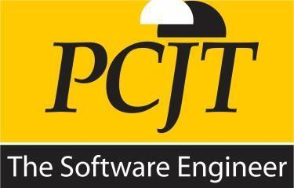

**Software Application Development**

**Project Documentation**

**Project Name**

Narwhals Colombo

Morawakage Akinda Methmika Perera

200421803135

